# **Exercise 5: Configuring the Spring IoC Container**

## **Scenario**

Your Library Management application requires a central Spring IoC Container to manage beans and their dependencies using XML configuration.

## **Step 1: Create Spring Configuration File**

**File: src/main/resources/applicationContext.xml**

<?xml version="1.0" encoding="UTF-8"?>  
<beans xmlns="http://www.springframework.org/schema/beans"  
 xmlns:xsi="http://www.w3.org/2001/XMLSchema-instance"  
 xsi:schemaLocation="  
 http://www.springframework.org/schema/beans  
 http://www.springframework.org/schema/beans/spring-beans.xsd">  
  
 <!-- BookRepository bean -->  
 <bean id="bookRepository" class="com.library.repository.BookRepository"/>  
  
 <!-- BookService bean with dependency injected -->  
 <bean id="bookService" class="com.library.service.BookService">  
 <property name="bookRepository" ref="bookRepository"/>  
 </bean>  
  
</beans>

This defines both beans and uses setter injection to wire BookRepository into BookService.

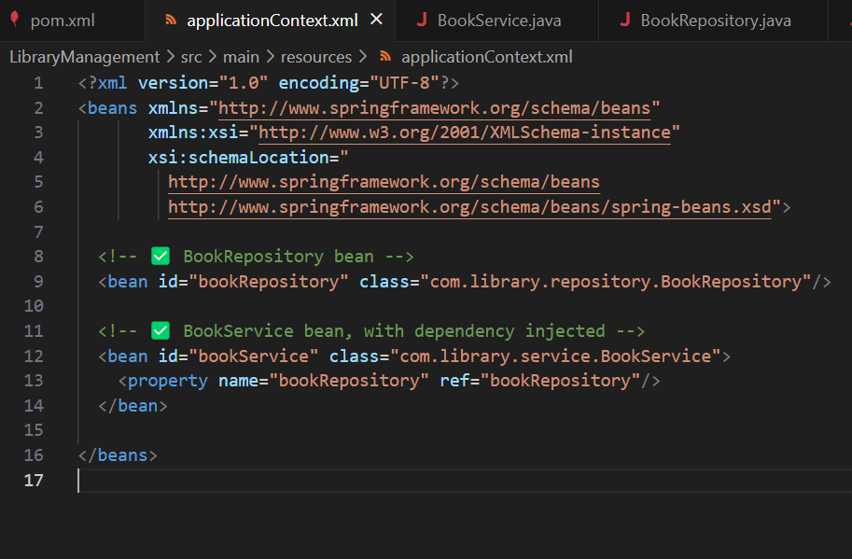

## **Step 2: BookService Class**

**File: src/main/java/com/library/service/BookService.java**

package com.library.service;  
  
import com.library.repository.BookRepository;  
  
public class BookService {  
  
 private BookRepository bookRepository;  
  
 // Setter for DI  
 public void setBookRepository(BookRepository bookRepository) {  
 this.bookRepository = bookRepository;  
 }  
  
 public void addBook(String title) {  
 bookRepository.saveBook(title);  
 }  
}

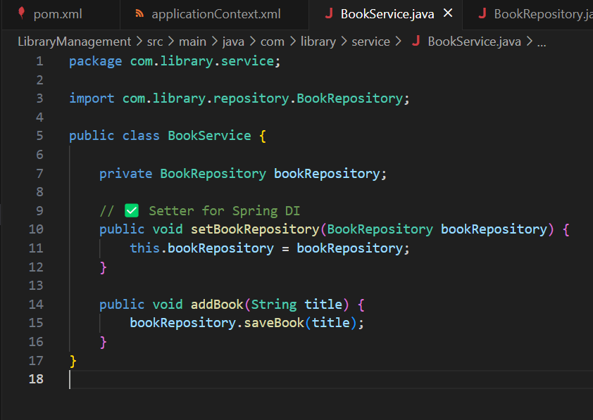

**File: src/main/java/com/library/repository/BookRepository.java**

package com.library.repository;  
  
public class BookRepository {  
  
 public void saveBook(String title) {  
 System.out.println("Book saved: " + title);  
 }  
}

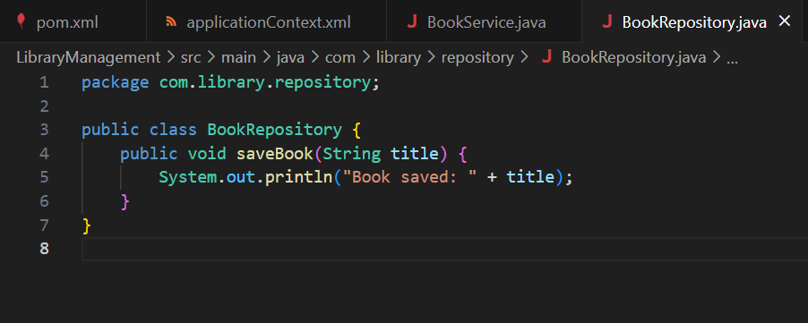

## **Step 3: Run the Application**

**File: src/main/java/com/library/LibraryApplication.java**

package com.library;  
  
import com.library.service.BookService;  
import org.springframework.context.ApplicationContext;  
import org.springframework.context.support.ClassPathXmlApplicationContext;  
  
public class LibraryApplication {  
  
 public static void main(String[] args) {  
 // Load Spring context from XML  
 ApplicationContext context = new ClassPathXmlApplicationContext("applicationContext.xml");  
  
 // Get BookService bean  
 BookService bookService = context.getBean("bookService", BookService.class);  
  
 // Call method to test DI  
 bookService.addBook("Spring IoC Example");  
  
 ((ClassPathXmlApplicationContext) context).close();  
 }  
}

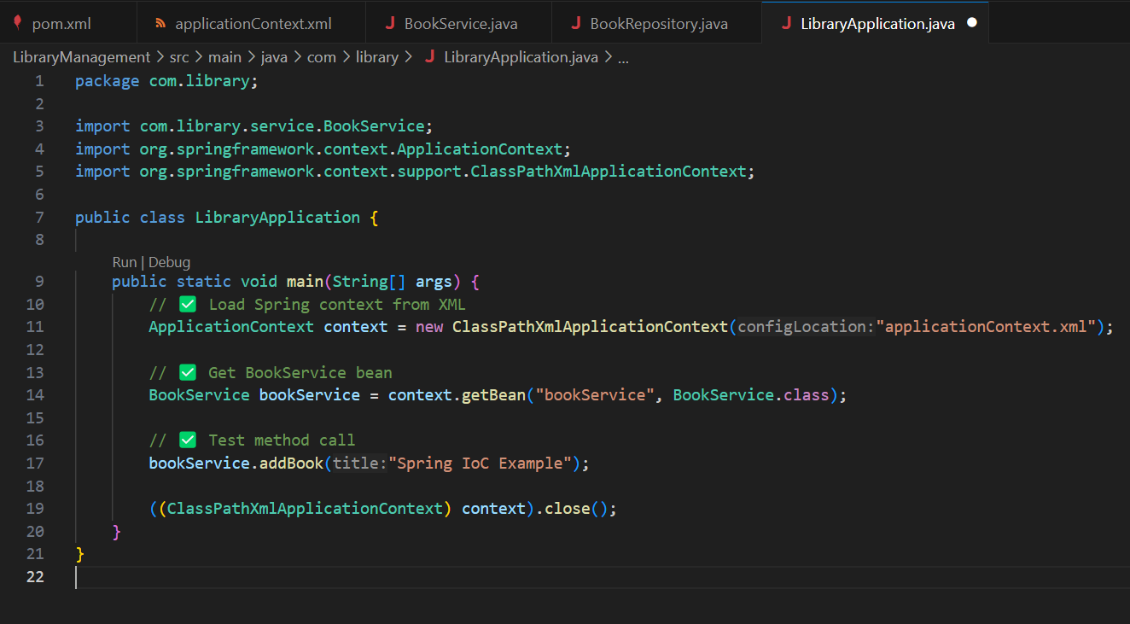

## **How to Run**

In the project root:

mvn compile  
mvn exec:java

**Expected Output:**

Book saved: Spring IoC Example

